Homework 6
Due: Friday, Mar 6, 11:59 PM PT

Instructions
For each of the problems below, design a dynamic programming (DP) algorithm by answering the following sub-parts:

a) Define in plain English the subproblem that your dynamic programming algorithm solves. In other words, your answer should be something like “OPT(x,y) denotes the min/max/… value obtained from x items/people/… with y time/money/…” and so on. Do not merely paraphrase the given problem or describe the high-level approach. (2 points)

b) Define the recurrence relation that computes the result of the subproblem in terms of the result of the smaller subproblems. (2 points)

c) Using the recurrence relation in part b, write pseudocode to find the solution. Make sure you specify all base cases and their values, as well as the final result of the problem. (4 points)

d) What is the time complexity of the solution? (2 points)

Problem 1
A rope has a length of n units, where n is an integer > 2. You are asked to cut the rope (at least once) into smaller pieces of integer lengths so that the product of the lengths of these smaller ropes is maximized. Design a DP algorithm to find the maximum product.

Solution 1:
a) Let OPT(i) denote the maximum product obtainable by breaking a rope of length i into one or more integer-length pieces.

b) For a rope of length i, we can make the leftmost cut at integer position j, where 0 < j < i. This results in a piece of length j and a remaining piece of length i - j. For the remaining piece, we can either leave it as is or continue breaking it further (which is represented by OPT(i-j)).
OPT(i) = max{ j × max(i - j, OPT(i - j))
c)
OPT[1] = 1
for i = 2 to n:
current_max = 0
for j = 1 to i - 1:
option = j * max(i - j, OPT[i - j])
if option > current_max:
current_max = option
OPT[i] = current_max
return OPT[n]

d) O(n^2)

Solution 2:
Claim: An optimal solution can only contain pieces of length < 5.
Proof: Assume an optimal solution contains a piece of length k ≥ 5. Cutting out a piece of length 3 from it always gives a better solution, since 3*(k-3) > k for all k ≥ 5. This implies that an optimal solution cannot contain any piece of length ≥ 5.

a) Let OPT(i) denote the maximum product obtainable by breaking a rope of length i into one or more integer-length pieces.

b) For a rope of length i, we can make the leftmost cut at integer position j, where 0 < j < min(i, 5). This results in a piece of length j and a remaining piece of length i - j. For the remaining piece, we can either leave it as is or continue breaking it further (which is represented by OPT(i-j)).
OPT(i) = max{ j × max(i - j, OPT(i - j))
c)
OPT[1] = 1
for i = 2 to n:
current_max = 0
# The inner loop runs at most 4 times and therefore takes O(1) time
for j = 1 to min(i - 1, 4):
option = j * max(i - j, OPT[i - j])
if option > current_max:
current_max = option
OPT[i] = current_max
return OPT[n]

d) O(n)
Problem 2
Suppose you are building a tool for a social media platform. Users often write hashtags without spaces, like #applepie or #nowhiring. Design a DP algorithm that determines if a long, unspaced hashtag of length n is made up of valid words from a given language dictionary. Assume dictionary lookup and substring slicing take O(1) time.
Example 1: If s = “applepie”, d = {“app”, “apple”, “pie”}, the answer is True.
Example 2: If s = “nowhiring”, d = {“no”, “hire”, “ring”}, the answer is False.

Solution:
a) Let OPT(i) denote whether the prefix of the string s up to i (s[1…i]) can be segmented into a sequence of one or more valid dictionary words.

b) To determine if OPT(i) is true, we look for some split point j such that the prefix up to j is valid, and the remaining substring from j+1 to i is a valid word in the dictionary.
OPT(i) = ⋁{OPT(j) ∧ (s[j+1…i]) ∈ d}

c)
OPT[0] = True
for i = 1 to n:
for j from 0 to i - 1:
if OPT[j] == True AND s[j+1...i] is in d:
OPT[i] = True
break
return OPT[n]

d) O(n^2)

Problem 3
Alice and Bob worked in a restaurant and received n currency notes in total as tips. Every note has a value written on it. The currency notes are arranged from left to right on a table in a fixed but arbitrary sequence. In particular, they are not necessarily sorted according to value. Alice and Bob play the following game to split the tip money. Alice and Bob take turns to play, and at each turn, the player chooses either the leftmost note or the rightmost note and takes it. Bob is greedy and always plays using the following strategy: If the rightmost note has a value larger than the leftmost, then take the rightmost. Otherwise, take the leftmost. Design a DP algorithm that determines the maximum amount of money Alice can get in total. Assume n is even and Alice plays the first turn.

Solution:
a) Let OPT(i, j) denote the maximum total amount Alice can get from the subarray of notes V[i…j], given that it is currently Alice's turn and Bob will play greedily on his subsequent turn.

b) When it is Alice's turn with the range [i, j], she has two choices:
- Take the leftmost note (V[i]): The remaining range is [i+1,j]. Bob will then take either V[i+1] or V[j] based on his greedy strategy.
- Take the rightmost note (V[j]): The remaining range is [i, j-1]. Bob will then take either V[i] or V[j-1] based on his greedy strategy.

OPT(i, j) = max{V[i] + Remaining(i+1, j), V[j] + Remaining(i, j-1)}
where Remaining(low, high) represents the subproblem after Bob makes his move:
If Bob faces [i+1, j]:
- If V[j] > V[i+1], Bob takes V[j], leaving OPT(i+1, j-1) for Alice.
- Otherwise, Bob takes V[i+1], leaving OPT(i+2, j) for Alice.
If Bob faces [i, j-1]:
- If V[j-1] > V[i], Bob takes V[j-1], leaving OPT(i, j-2) for Alice.
- Otherwise, Bob takes V[i], leaving OPT(i+1, j-1) for Alice.

c)
# Base Case: When only 2 notes are left, Alice takes the max, Bob gets the min.
for i = 0 to n-2:
OPT[i][i+1] = max(V[i], V[i+1])

# Fill table for subarray lengths k = 4, 6, ..., n (even steps)
for length = 4 to n step 2:
for i = 0 to n - length:
j = i + length - 1

# Option 1: Alice takes V[i], Bob looks at V[i+1] and V[j]
if V[j] > V[i+1]:
res1 = V[i] + OPT[i+1][j-1]
else:
res1 = V[i] + OPT[i+2][j]

# Option 2: Alice takes V[j], Bob looks at V[i] and V[j-1]
if V[j-1] > V[i]:
res2 = V[j] + OPT[i][j-2]
else:
res2 = V[j] + OPT[i+1][j-1]

OPT[i][j] = max(res1, res2)
return OPT[0][n-1]

d) O(n^2)

Ungraded Problem 1
Given a set of positive integers, design a DP algorithm to check whether it can be partitioned into two subsets such that the sum of the elements in both subsets is equal.

Solution:
a) Let OPT(j, s) = true if sum s can be achieved using the first j numbers A[1…j], false otherwise. (0 ≤ s ≤ T, 0 ≤ j ≤ n). Here, T equals half the sum of all numbers in A.

b) Recurrence: OPT(j, s) = OPT(j-1, s-A[j]) ∨ OPT(j-1,s) (∨ denotes logical OR)
The two terms of the recurrence correspond to whether A[j] is chosen or not.

c)
T = Sum(A)/2
For j = 0 to n:
OPT[j][0] = True
For s = 1 to T:
OPT[0][s] = False
For j = 1 to n:
For s = 1 to T:
If s < A[j]:
OPT[j][s] = OPT[j − 1][s]
Else:
OPT[j][s] = OPT[j − 1][s] OR OPT[j -1][s-A[j]])
Return OPT[n][T]

d) O(nT)

Ungraded Problem 2
Given n balloons, indexed from 1 to n. Each balloon is painted with a number on it, represented by an array of numbers. You are asked to burst all the balloons. If you burst balloon i, you will get nums[left] × nums[i] × nums[right] coins. Here left and right are adjacent indices of i. After the burst, the left and right then become adjacent. You may assume nums[0] = nums[n+1] = 1, and that balloons 0 and n+1 are not real therefore you can not burst them. Design a DP algorithm to find the maximum coins you can collect by bursting the balloons wisely.
Example: A = [3, 1, 5, 8]. The optimal solution is 167, where you burst balloons in the order of 1, 5, 3, and 8. The remaining balloons after each step is:
[3, 1, 5, 8] → [3, 5, 8] → [3, 8] → [8] → []
And the coins you get are:
3 × 1 × 5 + 3 × 5 × 8 + 1 × 3 × 8 + 1 × 8 × 1 = 167

Solution:
a) Let OPT(i, j) denote the maximum coins obtainable by bursting all balloons between index i and index j (where i and j are the boundaries that remain unburst).

b) For a range (i, j), let k be the index of the last balloon to be burst in that range (i < k < j). When k is the last to go, its neighbors are the original boundaries i and j.
OPT(i, j) = max{OPT(i, k) + OPT(k, j) + (A[i] × A[k] × A[j])}

c)
For i = 0 to n+1:
For j = 0 to n+1:
OPT[i][j] = 0
For length = 2 to n+1:
For i = 0 to n - length + 1:
j = i + length
For k from i + 1 to j - 1:
current_coins = OPT[i][k] + OPT[k][j] + (A[i] * A[k] * A[j])
OPT[i][j] = max(OPT[i][j], current_coins)
Return OPT[0][n+1]

d) O(n^3)

Ungraded Problem 3
Shawn decided to go on a trip for spring break, so he decided to visit San Francisco and went to see his favorite monument, the Golden Gate Bridge. Immediately, Shawn decided to take a picture of the magnificent bridge; however, due to its size, he was unable to fit the entire bridge in one picture. Relying on his expertise as a computer scientist, Shawn decided to take two pictures from the bridge and stitch the images together when he got back home. Now Shawn is back from his trip and can’t wait to show his friends the pictures from his trip. He knows that simply putting his two images together would show the lack of his photographic skills to his friends, so he decides to stitch the two images together such that the stitching is not obvious. To do this, he knows that the two images have the same height H and share 5 columns of pixels together, so he calculates the absolute difference in pixel values for every pair of pixels of the two images in the shared area. His goal is to find a path through the pixels in the shared area that minimizes the total sum of pixel differences. Furthermore, he knows that once he selects a pixel, he can select one that is either directly above it or diagonally above it as the next pixel, because otherwise the stitching becomes way too obvious. Help Shawn find the best path to stitch his images so that he can show off in front of his friends. The figure below provides an abstract representation of what Shawn is attempting to do.
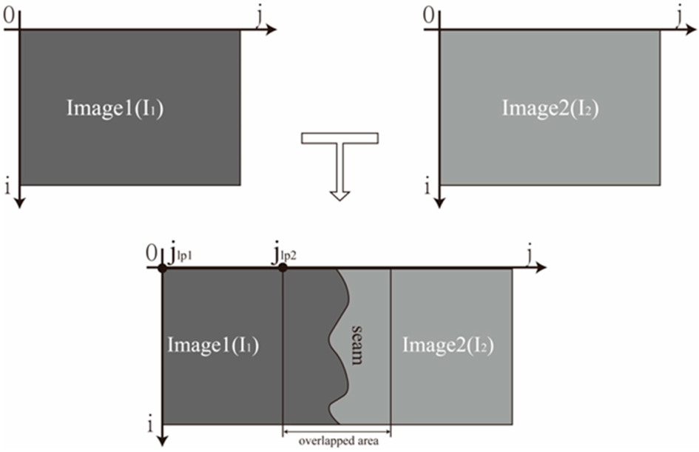

Solution:
a) Let OPT[i, j] = the minimum sum of pixel difference between two images from the bottom of the shared part to the pixel [i,j]

b)
+ diff(i,j)

c) For demonstration, the pseudo-code below includes the computation of the actual path that minimizes the values, rather than only computing the minimum value
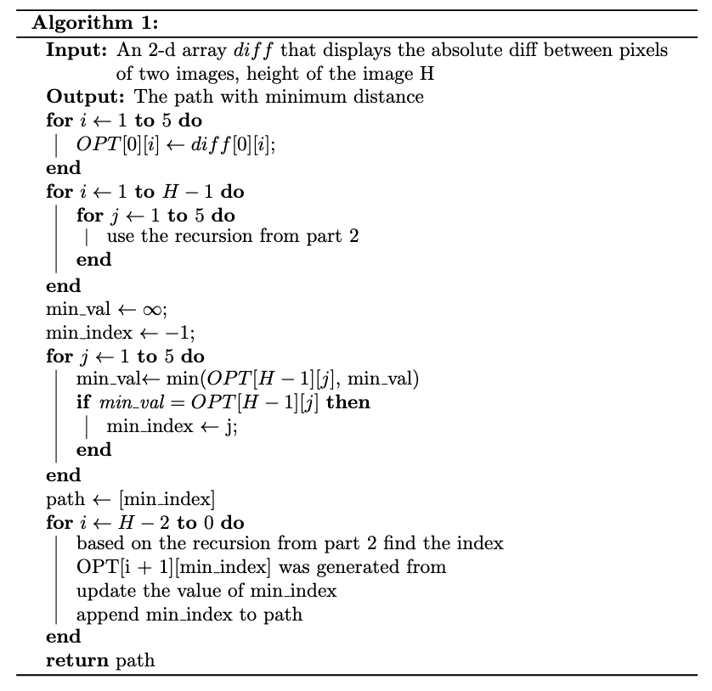

d) O(H)

